Project Report
On

“HUMAN RESOURCE ATTRITION DATA ANALYSIS USING TABLEAU “
by
Miss. XXXXX XXXXXX
“Your Course Name”
APPENDIX - I
CERTIFICATE FROM THE GUIDE

This is to certify that the Project work titled Sales and Marketing Data Analysis using Tableau Is a bonafide work carried out by Miss. “Your Name” Roll # 00000000 a candidate for the B.Com examination of the Institute of Management under my guidance and direction

SIGNATURE OF GUIDE
NAME XXXXX XXXXXX
DESIGNATION: Manager, Projects & Logistics
ADDRESS Maersk Line, C.G.House,
Mumbai
DATE: 20-03-2021
PLACE: Mangalore
TABLE OF CONTENTS
CHAPTER |  | DESCRIPTION | PAGE NO
1 |  | INTRODUCTION TO HUMAN RESOURCE ANALYTICS
 | 1.1 | WHAT IS ATTRITION
 | 1.2 | TYPES OF ATTRITION
 | 1.3 | CAUSES OF ATTRITION
2. |  | INTRODUCTION TO BUSINESS ANALYSIS TOOL TABLEAU
 | 2.1 | WHY BUSINESS INTELLIGENCE IS IMPORTANT
 | 2.2 | HOW BUSINESS INTELLIGENCE WORK
 | 2.3 | THE FUTURE ROLE OF BUSINESS INTELLIGENCE
3 |  | THE HYPER GROWTH OF DIGITAL ECONOMY
 | 3.1 | MARKET REPORTS AND INFORMATION ON THE CONSUMER ONLINE INDUSTRY
 | 3.2 | TALKING ABOUT E GENERATION
4 |  | RESEARCH METHODOLOGY
 | 4.1 | ATTRITION AND EMPLOYEE STOCK OPTION PLAN (ESOP)
 | 4.2 | ATTRITION AND PERCEPTION ABOUT GROWTH OPPORTUNITIES
 | 4.3 | ATTRITION AND PERCEPTION ABOUT GROWTH OPPORTUNITIES
5 |  | BUSINESS INTELLIGENCE MODEL
 | 5.1 | KEY PERFORMANCE INDICATOR (KPI)
 | 5.2 | JOB ROLE WITH CURRENT YEAR
 | 5.3 | PROMOTIONS
 | 5.4 | NUMBER OF MANAGER
 | 5.5 | PLANNING FOR RESIGNATION
6 |  | TABLEAU DASHBOARD
 | 6.1 | CREATING DASHBOARD
7 |  | CONCLUSION
8 |  | EXPERT COMMENTS
 |  | BIBLIOGRAPHY

LIST OF FIGURES

SL NO | NAME OF THE FIGURE | PAGE NO
1.1 | HR ATTRITION LIFE CYCLE
2.2 | THE MODERN ANALYTICS WORKFLOW
3.2 | BUY – SIDE VS SELL - SIDE
5.1 | KEY PERFORMANCE INDICATOR (KPI)
5.2 | ROLE WITH CURRENT YEAR
5.3 | PROMOTIONS
5.4 | NUMBER OF MANAGER
5.5 | PLANNING FOR RESIGNATION
6.1 | CREATING WORKSHEET
6.1.1 | CREATING MULTIPLE SHEET
6.1.2 | BLACK DASHBOARD SHEET
6.1.4 | COMBINING MULTIPLE WORKSHEET
6.1.5 | EMPLOYEE ATTRITION DASHBOARD

CHAPTER – 1
INTRODUCTION TO HUMAN RESOURCE ANALYTICS
Attrition in human resources refers to the gradual loss of employees over time. In general, relatively high attrition is problematic for companies. HR professionals often assume a leadership role in designing company compensation programs, work culture and motivation systems that help the organization retain top employees. A major problem in high employee attrition is its cost to an organization. Job postings, hiring processes, paperwork and new hire training are some of the common expenses of losing employees and replacing them. Additionally, regular employee turnover prohibits an organization from increasing its collective knowledge base and experience over time. This is especially concerning if the business is customer facing, as customers often prefer to interact with familiar people. Errors and issues are more likely if the organization has constantly new workers.
Retaining the employees involves understanding the intrinsic motivators as individuals differ a lot. Retaining employees is a critical and ongoing effort. Staff requires reinforcement, direction and recognition to grow and remain satisfied in their positions. Managers must recognize this and understand that establishing such fundamentals demonstrates their objectives to support nature and motivate their employees. This study is an outcome of the topic called “A Study on Attrition Management”. This research is an attempt to find out the causes of attrition from different dimensions and have proposed some ways in which this issue can be addressed.
It undertakes the effect of the same on employer and employee both. In this research, I have made an attempt to bring out employee retention approaches, strategies for retention and the costs related to attrition. Following this some strange reasons for attrition have been discussed in this regard. The positive side of attrition has also been discussed upon. Further, the remedial measures have been discussed herein. Managing attrition is not just a 'nice thing to do', it is the route to survival. Whenever a well-trained and well-adapted employee leaves the organization, it creates a vacuum. So, the organization loses key skills, knowledge and business relationships. Modern managers and personnel administrators are greatly interested in reducing Attrition in the organization, in such a way that it will contribute to the maximum effectiveness, growth, and progress of the organization. Attrition costs a lot. It's one of the largest costs in all types of organizations, yet it's also one of the least understood. Organizations need to find new approaches to retain the most effective manpower.

1.1 : WHAT IS ATTRITION

Attrition is defined as a gradual reduction of the size of workforce through normal means, such as retirement, resignation or death. This is normal in any business and industry. Attrition rate is defined as the rate of shrinkage in size or number. This type of reduction in staff is one way a company can decrease labour costs: the company simply waits for its employees to leave and freezes hiring. Attrition of employees in a limited measure is desirable for influx of new ideas in any type of organization. It helps organizations to maintain their agility in fast changing environment. It brings in new blood, opens up new vistas for change, development and improvement, shows avenues to expand operations and add to the creative lines of the organizations. Attrition in a limited measure can thus bring gains to the organization. However if attrition increases beyond a certain level, the gains are transformed into pains. Recruiters explain that high attrition rates significantly increase the investment made on. Significant investments in time and money need to be made for acquiring employees in any organization. These can never be translated into profit when attrition is high.

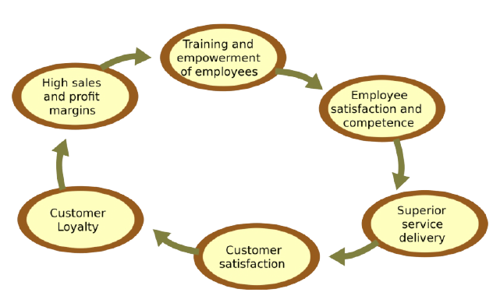
FIG NO. 1.1 : HR ATTRITION LIFE CYCLE
Hence urge for employee retention arises. Effective employee retention is a systematic effort by employers to create and foster an environment that encourages current employees to remain employed by having policies and practices in place that address their diverse needs. The organization is fully at loss when employees leave their job once they are fully trained. Employee retention takes into account the various measures taken so that an individual stays in the organization for the maximum period of time. It is beneficial both for the organization as well as the employee.

1.2 : TYPES OF ATTRITION

- Voluntary attrition- Voluntary attrition takes place when the employee leave the organization by their own will. Pull factors like higher emoluments elsewhere, better opportunities of growth and promotion etc. are responsible for this kind of attrition.
- Involuntary attrition- Involuntary attrition takes place when the employees leave the organizations due to some negative forces or push factors like faulty promotion policy, biased performance appraisal etc.
- Compulsory attrition- It takes place due to the rules and regulations of the government and that of the organization as well. It includes attrition taking place due to attaining the age of retirement, completion of tenure etc.
- Natural attrition- It takes place due to the causes and factors that are beyond the control of the individual and organization as well. These factors may include end of life, insanity etc.

1.3 : CAUSES OF ATTRITION

Internal causes-
These causes are pertaining to the internal environment of an organization. Therefore, they are controllable.
Salary
a. Insufficient salary.
b. Delay in payment.
c. No / delayed increment.
. Wage compression.

Promotion
a. Biased promotion
b. No / delayed promotion
Transfer
a. Forceful transfer.
b. Transfer to a place employee is not willing to go.
Workplace Infrastructure & amenities
a. Lack of hygiene
b. Lack of basic facilities like water, canteen, etc.
External causes-
These are the causes which are beyond the control of an organization as they belong to the external environment. These causes may be related to:
a. Better pay.
b. Chances of promotion.
c. Better perks.
d. More fringe benefits in other organizations.

Individual/Personal causes
a. End of life
b. Marriage
c. Pregnancy
d. Shift of family
e. Mental imbalance
f. Over - sensitivity
g. Wish to go abroad
h. Attrition of the group members
i. Self-employment
j. Education

CHAPTER – 2
INTRODUCTION TO BUSINESS ANALYSIS TOOL TABLEAU

Business intelligence (BI) combines business analytics, data mining, data visualization, data tools and infrastructure, and best practices to help organizations to make more data-driven decisions. In practice, you know you’ve got modern business intelligence when you have a comprehensive view of your organization’s data and use that data to drive change, eliminate inefficiencies, and quickly adapt to market or supply changes.
It’s important to note that this is a very modern definition of BI—and BI has had a strangled history as a buzzword. Traditional Business Intelligence, capital letters and all, originally emerged in the 1960s as a system of sharing information across organizations. It further developed in the 1980s alongside computer models for decision-making and turning data into insights before becoming specific offering from BI teams with IT-reliant service solutions. Modern BI solutions prioritize flexible self-service analysis, governed data on trusted platforms, empowered business users, and speed to insight.
Much more than a specific “thing,” business intelligence is rather an umbrella term that covers the processes and methods of collecting, storing, and analyzing data from business operations or activities to optimize performance. All of these things come together to create a comprehensive view of a business to help people make better, actionable decisions.
Over the past few years, business intelligence has evolved to include more processes and activities to help improve performance. These processes include:
- Data mining: Using databases, statistics and machine learning to uncover trends in large datasets.
- Reporting: Sharing data analysis to stakeholders so they can draw conclusions and make decisions.
- Performance metrics and benchmarking: Comparing current performance data to historical data to track performance against goals, typically using customized dashboards.
- Descriptive analytics: Using preliminary data analysis to find out what happened.
- Querying: Asking the data specific questions, BI pulling the answers from the datasets.
- Statistical analysis: Taking the results from descriptive analytics and further exploring the data using statistics such as how this trend happened and why.
- Data visualization: Turning data analysis into visual representations such as charts, graphs, and histograms to more easily consume data.
- Visual analysis: Exploring data through visual storytelling to communicate insights on the fly and stay in the flow of analysis.
- Data preparation: Compiling multiple data sources, identifying the dimensions and measurements, preparing it for data analysis.

2.1 : WHY IS BUSINESS INTELLIGENCE IMPORTANT
Business intelligence can help companies make better decisions by showing present and historical data within their business context. Analysts can leverage BI to provide performance and competitor benchmarks to make the organization run smoother and more efficiently. Analysts can also more easily spot market trends to increase sales or revenue. Used effectively, the right data can help with anything from compliance to hiring efforts.
A few ways that business intelligence can help companies make smarter, data-driven decisions:
- Identify ways to increase profit.
- Analyze customer behavior.
- Compare data with competitors.
- Track performance.
- Optimize operations.
- Predict success.
- Spot market trends.
- Discover issues or problems.

2.2 : HOW BUSINESS INTELLIGENCE WORK
Businesses and organizations have questions and goals. To answer these questions and track performance against these goals, they gather the necessary data, analyze it, and determine which actions to take to reach their goals. On the technical side, raw data is collected from the business’s activity. Data is processed and then stored in data warehouses. Once it’s stored, users can then access the data, starting the analysis process to answer business questions.
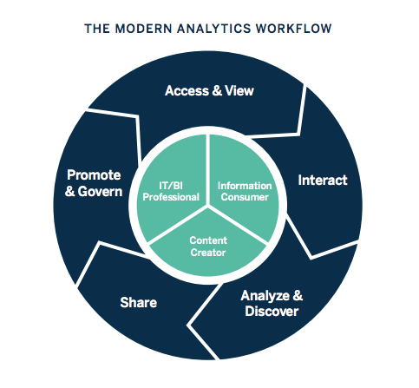
FIG NO. 2.2 : THE MODERN ANALYTICS WORKFLOW
Business intelligence includes data analytics and business analytics, but uses them only as parts of the whole process. BI helps users draw conclusions from data analysis. Data scientists dig into the specifics of data, using advanced statistics and predictive analytics to discover patterns and forecast future patterns. Data analytics asks “Why did this happen and what can happen next?” Business intelligence takes those models and algorithms and breaks the results down into actionable language.
2.3 : THE FUTURE ROLE OF BUSINESS INTELLIGENCE
Business intelligence is continually evolving according to business needs and technology, so each year, we identify current trends to keep users up-to-date on innovations. Realize that artificial intelligence and machine learning will continue to grow, and businesses can integrate the insights from AI into a broader BI strategy. As companies strive to be more data-driven, efforts to share data, and collaborate will increase. Data visualization will be even more essential to work together across teams and departments. This article is just an introduction to the world of business intelligence. BI offers capabilities for near real-time sales tracking, allows users to discover insights into customer behavior, forecast profits, and more. Diverse industries like retail, insurance, and oil have adopted BI and more are joining each year. BI platforms adapt to new technology and the innovation of its users. Stay up-to-date with all of the trends and changes in business intelligence as we list the top 10 current trends in BI.

CHAPTER – 3
THE HYPER GROWTH OF DIGITAL ECONOMY
While estimates vary widely:
- Retailing on the Internet accounted for less than 3% of total North American retail sales in 1998. Growth rates, however, have been very encouraging. It was estimated that in the year 2000 business-to-consumer Internet transactions worldwide has amounted to approximately $20-$50 billion, while business-to-business transactions has reached in the $50-$150 billion range.” (Industry Canada)
- Internet traffic is doubling every 100 days. Digital economy is doubling annually. Worldwide e-business was exceeded $1 trillion by 2002.(a survey)
- Canada is the most ‘wired’ nation, with the highest per capita rate of Internet-connected people. Forty-five percent of Canadians are online for a total of 13.5 million users. Americans rank first for the total number of users with 92 million people online, or 34 percent of the population. (NUA Internet Surveys, 1999)
- 61% of Canadian small and medium-sized enterprises (SME5) were connected to the Internet in 1999. (Internet Institute)
- Canada has the lowest Internet access cost in the world. (OECD, 1997)

3.1 : MARKET REPORTS AND INFORMATION ON THE CONSUMER ONLINE INDUSTRY:
- NUA Internet Surveys
- International Communications Inc.
- Jupiter Communications
- COM QUEST Research (Canadian data)
NEWS AND ANALYSIS.
China’s Mr. Internet: Jack Ma wants to build China’s first genuinely global Digital Economy firm - The Economist (Aug 26, 2000)
- Thinking Strategically about Selling Online - Ascenda
Home Internet use ‘growing’ - BBC News (Aug 7, 2000)
- Dairy industry turns to Digital Economy - CNN (Jul 28, 2000)
- Online shopping gets more convenient - BBC News (Jul 27, 2000)

ALL DIGITAL ECONOMY
- Digital Economy Times: getting started, strategies, news and reports.
- Focuses on buying and selling over the Internet, along with ongoing issues that will impact the future of electronic commerce.
- The Agricultural Forum (U.S.) has a series of papers on the effects of Digital Economy in the agri food industry.
- Digital Economy survey by The Economist

3.2 : TALKING’ ABOUT E-GENERATION
Student opinions report by The Economist, Most business owners understand the idea of conducting business over the Internet, and probably understand the need to “get their business online” but what is Digital Economy, really, and how do you get started?

In a nutshell, Digital Economy is a way of conducting business through computers and over networks. Simply put, Digital Economy is buying and selling over the Internet. But it’s actually much more than that. Business interactions of all types-from simple buying and selling, to complex business practices such as banking, manufacturing, and supply chain management-can be easily accomplished using the Internet along with real time data.
Buy-Side vs. Sell-Side: Digital Economy
There are two basic sides to Digital Economy; the Buy Side and the Sell Side
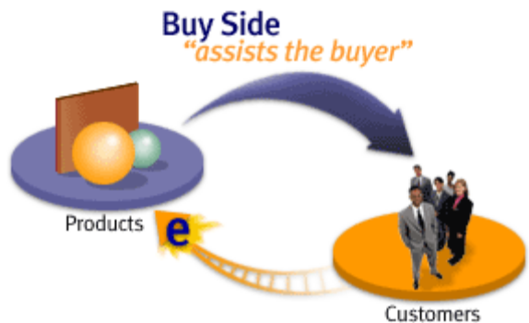
FIG NO. 3.2 : BUY – SIDE VS SELL - SIDE
Buy Side
Customers
Buy Side refers to the Digital Economy functionality that enables a business to sell their products to a buyer (customer) online. This buyer could be an individual consumer or a large company buying products for commercial use. The purpose is to make online buying easier and the experience more pleasant for the buyer. The more robust the choice in conjunction with an easier, user- friendly web site, customer satisfaction increases and so do sales.
Sell Side refers to the Digital Economy functionality that enables a company to actually make their goods and services available over the Internet. Critical to the success of the seller, it assists the seller in improving internal business processes and functionality. The purpose is to help companies increase revenue and profitability by reducing business and procurement costs. Since Digital Economy is a relatively new phenomenon, the definitions and jargon are not necessarily embedded into our everyday business lexicon.

CHAPTER – 4
RESEARCH METHODOLOGY
4.1 : ATTRITION AND EMPLOYEE STOCK OPTION PLAN (ESOP)

A peculiar paradox has been observed in case of ESOP as a motivational tool and the attrition rate. Generally it is perceived that ESOP on one hand generate funds for the organization and on the other hand it may curb attrition rate as it increases participation of employees in management, increase in their financial resources and satiation of their esteem needs as well which will ultimately lead to their long- term commitment with the organization. However, while considering an altogether different perspective, ESOP may increase the rate of attrition as the earning from ESOP may be sufficient for the livelihood of the employee or it may sometimes exceed his income leading to his disinterest to continue the job.

4.2 : ATTRITION AND PERCEPTION ABOUT GROWTH OPPORTUNITIES
- Employer’s perception and presumptions - Employers may have a perception that employees are already well aware of their growth and career opportunities in the organization or they may perceive that the old staff will convey the things to the new one. But actually the new workers may not be aware of these things, further they can be misguided and misled by their colleagues.
- Employee’s perception- Employees may have a perception that:
a. Employers may get annoyed if they are asked about the career opportunities in the organization
b. Employers may take it negatively which may be detrimental to job security, increment and promotion etc.
c. If there are growth opportunities, employers will themselves convey the same and their silence means there is no scope of growth in the organization.

4.3 : EXPLORATORY DATA ANALYSIS (EDA)
Generally one of the first few steps in exploring the data would be to have a rough idea of how the features are distributed with one another. To do so, kdeplot function from the Seaborn plotting library in python is used to generate kernel density bivariate plots. A density plot visualises the distribution of data over a continuous interval or time period. An advantage density plots have over histograms is that they are better at determining the distribution shape because they are not affected by the number of bins used. A histogram comprising of only 4 bins wouldn’t produce a distinguishable enough shape of distribution as a 20-bin Histogram would. However, with density plots this isn’t an issue. These are given as follows:

Normally two types of data are used for the purpose of carrying out research. For this survey also I have collected these data i.e.
a. Primary data
b. Secondary data
Primary Data: Primary data is one, which is collected from fresh sources and for the first time while conducting the research. For the project, primary survey has been undertaken through a survey instrument consisting of structured questionnaire filled by employees by the way of personal interviewing
Secondary data: Secondary data is that data which has been collected for some other purpose. There are two types of sources for collecting secondary data: a. Internal sources b. External sources Internal sources of secondary data includes the data generated within the organization E.g. Employee Engagement Survey Result External sources of secondary data are the sources outside the organization E.g. Annual Publications, Books, Magazines and Internet etc.

CHAPTER – 5
BUSINESS INTELLIGENCE MODEL
Employee attrition is predictable under stable circumstances, wherein a set pattern can be deduced from certain parameters influencing the employee and the organization at all times. Some of these parameters could be foreseeable such as retirement age or unforeseeable such as company performance, external funding, management shakeup etc. On a basic level, the model works by clustering/ classifying employee profiles based on various attributes such as age, sex, marital status, education level, work experience, distance from hometown, etc. and generates various levels of risk of attrition. Occasionally, other parameters like performance over the years, pay raise, work batch, educational institution are also taken into consideration. Various statistical and machine learning algorithms are designed to construct the predictive models. For instance, ‘classification’ models catalog the employees based on their risk to leave the company; whereas ‘non-linear regression’ model gives the ‘probability of attrition’ when the outcomes are dichotomous.
Likewise, ‘decision trees’ model evaluate loss based on factors like gini index, information gain and variation reduction. For models involving multiple parameters, the decision trees tend to become very large and complex. In such circumstances, ‘Random Forest’ method combines several decision trees using multiple algorithms to classify and understand complexities and predictions. Besides, these models aim to provide good predictability. However, seamless implementation depends on choosing the right model.
Thus, different models are chosen based on the aforementioned parameters, data availability, budget, computational power and the requirements of decision makers. For example, in one organisation, a model using artificial neural network may provide better predictability than a decision tree model, but a decision tree model may be easier to understand and implement at a lower cost.Thus, depending on the organizational contexts, different models have to be tried and evaluated before making the final selection.

In our Project, we have considered following business model, such as
- Key Performance Indicator (KPI)
- Sales and Profit
- Sales by Region
- Profit Forecast
- Trend Lines of the Business.

5.1 : KEY PERFORMANCE INDICATOR (KPI)
Dashboard is a graphical user interface which provides at-a-glance views of the Key Performance Indicators (KPIs) relevant to a particular objective or business process. In other terms, dashboard could be referred to as a single source of view – in which disparate data sources are brought together and displayed in a single view. In many instances, dashboards are linked to the database to allow update of data which can be in real time or at different intervals of time.
Some of the benefits of using dashboards as a reporting tool are.
- Help user absorb information quickly; this is so because the brain can process images faster than it does on text.
- Dashboards help users understand the next steps; from the visual trends, understanding the next steps becomes much easier, with minimal time and energy dedicated to analysis and interpretation of insights.
- Dashboards helps grab the attention of users; Data visualizations relays the message quickly before users can lose interest
- Dashboards simplify update of data and sharing of insights
- By visualizing data, outliers which tend to drag analysis in the wrong directions can be easily spotted
- Dashboards help organizations save reporting time
- Dashboards enable organizations to bring disparate data sources together, gaining more visibility on the business and in the end consolidate reports in a single location
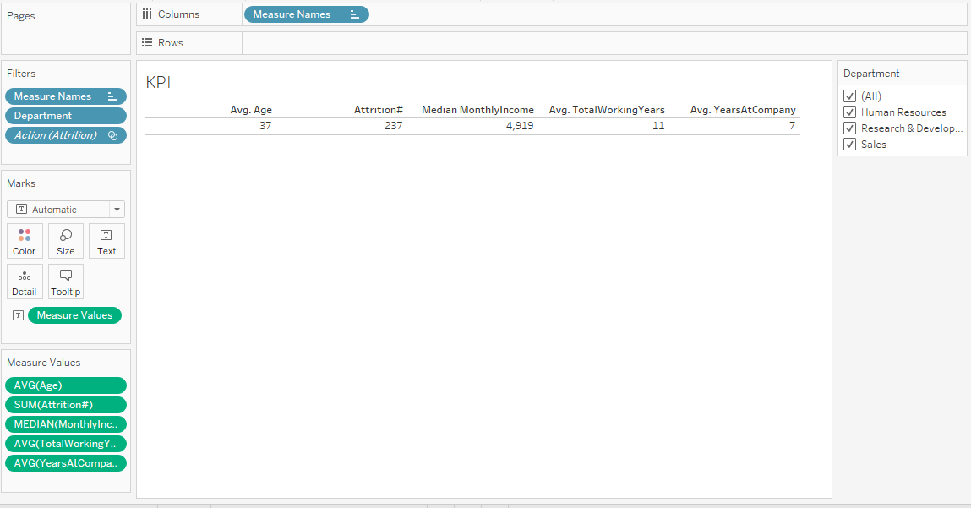
Fig No : 5.1 : KEY PERFORMANCE INDICATOR (KPI)
In the creation and assignment of human attrition, having a proactive approach can improve Average Age of the Employee. We have found that optimizing territory design can increase Attrition from two to seven percent without changes in resources. You need the data to understand the sales KPIs impacting your territories to better balance workloads across the field and easily see unworked opportunities. As per the KPI monthly income of the employee, Total working hours and Years at Company is shown.

5.2: JOB ROLE WITH CURRENT YEAR
Our Tableau dashboard comprised of the aforementioned charts. This interactive dashboard enables the consumer to understand job role with current year by trend, department, level of positins and maximum years of experience. Using actions in place of Quick Filters provides a number of years. First, the dashboard will load more quickly. Using too many Quick Filters or trying to filter a very large dimension set can slow the load time because Tableau must scan the data to build the filters. The more quick filters enabled on the dashboard, the longer it will take the dashboard to load. By creating a series of four-panel, four cascading dashboards the load speed was improved dramatically and the understandability of the information presented was greatly enhanced. The top-level dashboard provided a summary view, but included filter actions in each of the visualizations that allowed the executive to see data for different regions, products, and sales teams.
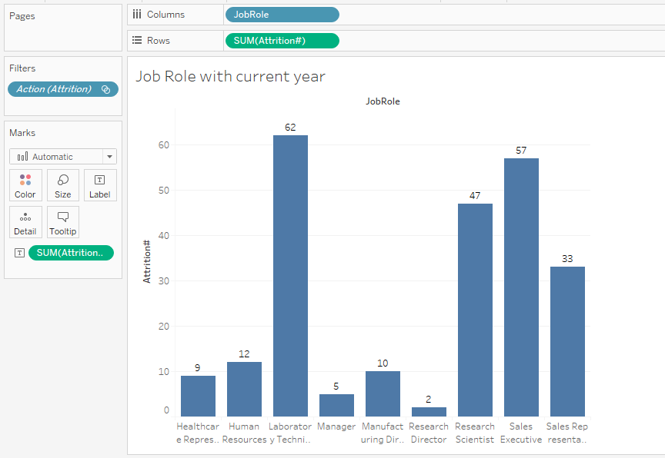
FIG NO. 5.2 : ROLE WITH CURRENT YEAR
A key feature of Job role by year in Tableau is interactivity. Dashboards are not simply a set of reports on a page; they should tell a story about the business. In order to facilitate the decision-making process, interactivity is an important part of assisting the decision-maker to get to the heart of the analysis as quickly as possible. This Dashboard, made on Tableau, visualizes the Sales and Profit Analysis of a Supermarket.
At a glance, you can see:
- The employee distribution of various categories relative to each other
- Their respective department and total number of employee with respect to divisions.
- Each Category’s Sub – Category Product Department.
- And finally, the Employee growth of Categories over the years
5.3 : PROMOTIONS
Perform an extensive exit survey/interview to understand how the company can improve to keep people from wanting to leave for other opportunities so much (retroactive approach). Perform surveys before employees desire to leave, geared towards understanding happiness, satisfaction, and so on. The areas to think about could include things like culture code, events and socials, performance reviews, and so on (preventative approach). The cost of turnover is immense. It should not be out of the question to consider offering employees more money to keep them around (preventative approach).
There are a lot of ways to approach pay analysis. I have chosen to divide the analysis into 2 sections. The first one is more of an overall review of the company pay status. It is reviewed by a dashboard that displays salary data by sex, age, position and pay range. This kind of dashboard should usually be put in the HR department in order to monitor the compatibility of salary data to the company pay strategy. In this dashboard, I decided not to investigate race differences since it is usually not relevant for most of the Israeli companies but I did check pay rate differences between males and females. The performance score distributes normal, exactly as it should be. Most of the employees fully meets expectations and the lower or grater scores has the lower frequency to make things easier, I assigned a number to each one of the scores so the 1 means the highest score and 5 means the lowest. Comparing the pay range with the performance score might give us an answer to the riddle of the high number of voluntary terminations.
This is probably the most compelling graph. First, we can see that most of the pay categories are evenly spread across the performance score. We can also see that usually the min-mid pay range is lower on the absolute pay than the mid-max pay range. But the most important conclusion about pay range and score appears on the “higher than pay range” category. Neither one of the employees that are paid higher than pay range didn’t receive the highest score. In fact, the optimal distribution should be a correlation between the performance and the pay. The highest the score the highest the pay range status.
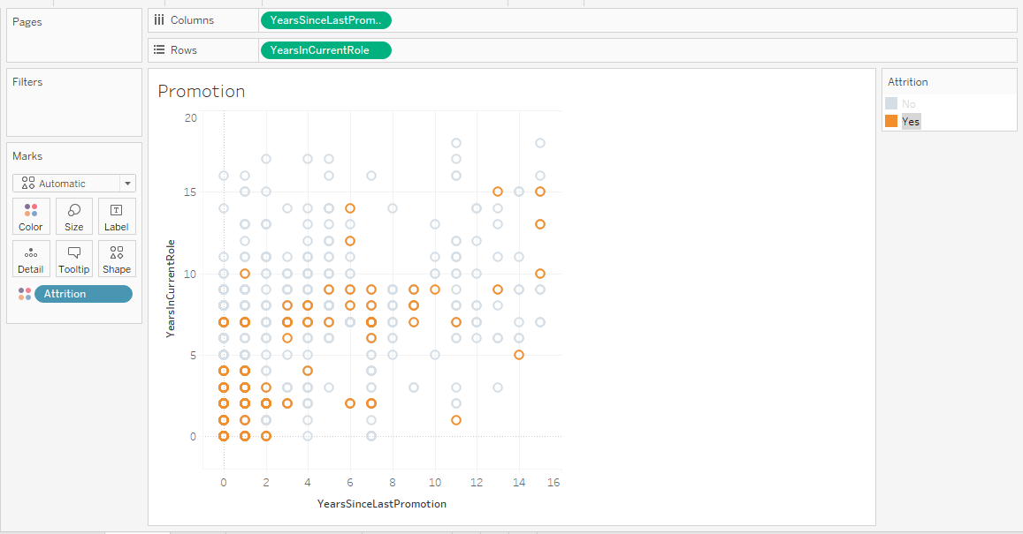
FIG NO. 5.3 : PROMOTIONS
Since we don’t have a lot of data on the company recruiting sources, we will need to set up some criterions to measure the efficiency.
- Cost- the agency will consider more efficient as the cost will be cheaper.
- Employee quality- the agency will consider more efficient as the employee will have a higher performance score.
- Years of service- the agency will consider more efficient as the years of service of the employee will be grater.
After setting these measures, we can visualize the data for better exploration. We can set an average agency cost, average years of service and average performance score as a reference for these measures.
These finding can save a lot of money spent on recruiting agencies that are relatively expensive but might not provide better employees than the other cheapest ones. One particular agency that seems efficient on both charts is the “professional society” agency. The cost is relatively cheap the provides quality employees. If I would need to choose an agency to work with, I would defiantly choose this one.
5.4 : NUMBER OF MANAGER
Employee mobility is at its peak now and will continue to grow in the future as more and more jobs becoming mobile-enabled. Employers and HR departments have to understand how it affects their organization to successfully overcame its challenges. Depending upon the complexity of a job and the level of management, the cost of turnover can equal anywhere from one month’s to several years’ salary for a departing employee. The more complex the job and the higher level of the job, the greater the cost.
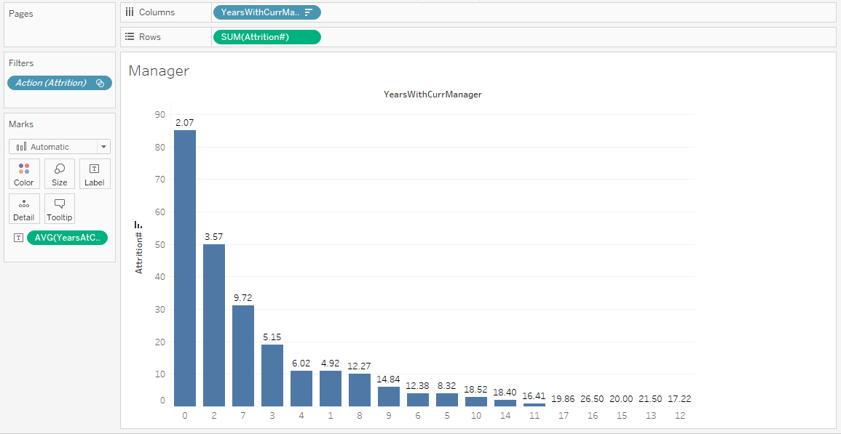
Fig No. 5.4 : NUMBER OF MANAGER
Each of the following examples indicate the structure that supports creating a number of manager.
- The field you want to forecast is on the Rows shelf and a continuous date field is on the Columns shelf.
- The field you want to forecast is on the Columns shelf and a continuous date field is on the Rows shelf.
- The field you want to forecast on either the Rows or Columns shelf, and discrete dates are on either the Rows or Columns shelf. At least one of the included date levels must be Year.
- The field you want to forecast is on the Marks card, and a continuous date or discrete date set is on Rows, Columns or Marks.
5.5 : PLANNING FOR RESIGNATION
“The ratio of the number of employees that leave a company through attrition, dismissal, or resignation during a period to the number of employees on payroll during the same period.” – Business dictionary Employee mobility is at its peak now and will continue to grow in the future as more and more jobs becoming mobile-enabled. Employers and HR departments have to understand how it affects their organization to successfully overcome its challenges.

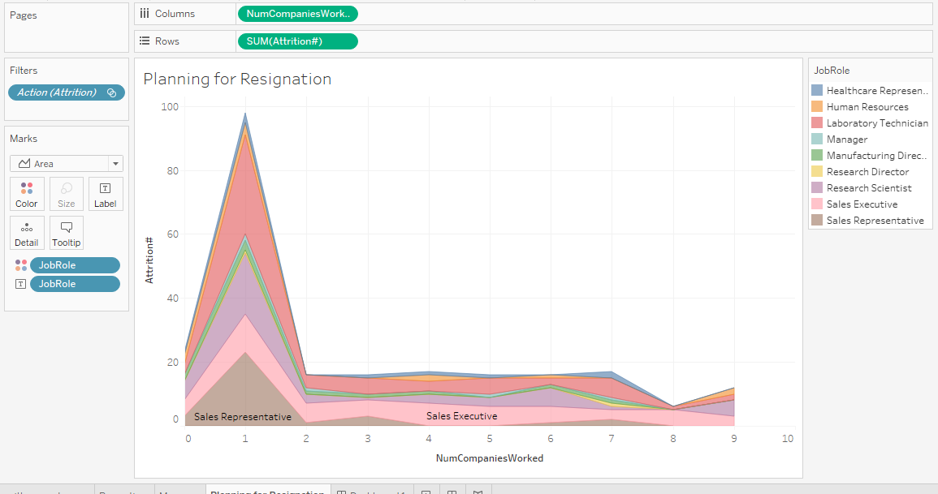
FIG NO. 5.5 : PLANNING FOR RESIGNATION
Turnover is the organizational movement of hiring and dismissing employees motivated by different reasons, such as termination, retirement, and resignations. High turnover rates can be harmful to organizational productivity, potentially disrupting investments in human resources, generating loss of tacit knowledge and non-scheduled costs with staff replacement. Usually, organizations are unprepared for premature employee resignation, and the problems arising from turnover are even more harmful in this case. Estimating the employee’s inclination to resignation is paramount to reduce turnover, thereby reducing its negative impact on organizational performance. In this article, we exploit LinkedIn to predict employee resignation likelihood. Particularly, we introduce the ERP approach, which collect professional profiles from LinkedIn and use them as a source of features about employee’s inclination to resignation. Additionally, we evaluate different algorithms used by ERP to classify employees, considering their resignation likelihood. Experimental results show that the decision tree is the most effective algorithm, classifying correctly more than 88% of the employees. Furthermore the kappa measure show a substantial agreement between the decision tree and an optimal classifier.
Employee retention is a key objective for most HR organizations, and employee turnover is the single most prevalent HR metric. However, knowing your turnover rate does little to support strategic business plans. To achieve true insight, a more in-depth analysis of what’s causing turnover in different parts of the organization is required.
Why should HR make employee retention a priority? Data from the Work Institute 2020 Retention Report reveals the state of employee retention and turnover.
- More than 75% of employees who quit could have been retained.
- Close to 40% of employees that leave an organization do so in the first year.
- Voluntary turnover costs exceeded $630 billion last year.
HR, with its understanding of human capital dynamics, is uniquely positioned in the organization to ensure the workforce is aligned with the needs of the business at the optimal cost. Now, more than ever, business leaders need strategic insight and the ability to model how turnover trends impact revenue and profits—quickly and accurately.

CHAPTER – 6
TABLEAU DASHBOARD
A dashboard is a consolidated display of many worksheets and related information in a single place. It is used to compare and monitor a variety of data simultaneously. The different data views are displayed all at once. Dashboards are shown as tabs at the bottom of the workbook and they usually get updated with the most recent data from the data source. While creating a dashboard, you can add views from any worksheet in the workbook along with many supporting objects such as text areas, web pages, and images.
Each view you add to the dashboard is connected to its corresponding worksheet. So when you modify the worksheet, the dashboard is updated and when you modify the view in the dashboard, the worksheet is updated.
6.1 : CREATING DASHBOARD
Using the Sample-superstore, plan to create a dashboard showing the sales and profits for different segments and Sub-Category of products across all the states. To achieve this objective, following are the steps.
Step 1 − Create a blank worksheet by using the add worksheet icon located at the bottom of the workbook. Drag the dimension Segment to the columns shelf and the dimension Sub-Category to the Rows Shelf. Drag and drop the measure Sales to the Color shelf and the measure Profit to the Size shelf. This worksheet is referred as the Master worksheet. Right-click and rename this worksheet as Key Performance Indicator (KPI). The following chart appears.
Tableau uses a workbook and sheet file structure, much like Microsoft Excel. A workbook contains sheets. A sheet can be a worksheet, a dashboard, or a story. A dashboard is a collection of views from multiple worksheets. A dashboard is a collection of views from multiple worksheets. The Dashboard and Layout panes are available in its side bar. For more details about creating dashboards, see Dashboards. A worksheet contains a single view along with shelves, cards, legends, and the Data and Analytics panes in its side bar. For details on the worksheet workspace, see The Tableau Workspace.
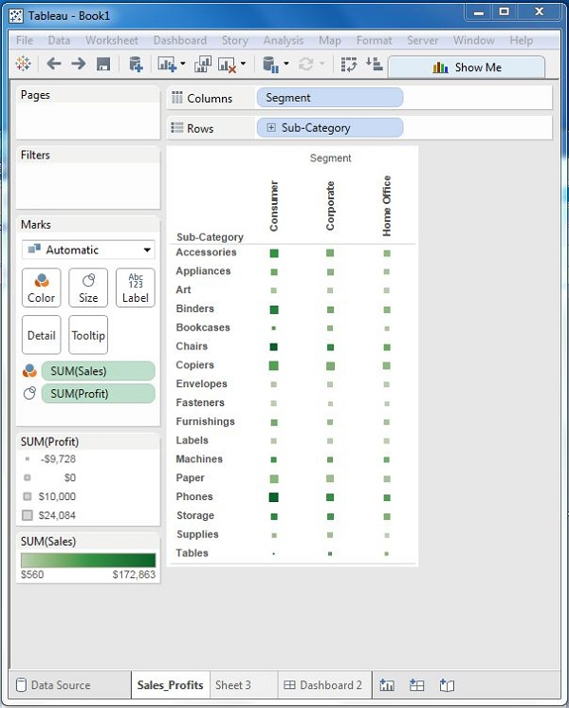
FIG NO. 6.1 : CREATING WORKSHEET
Step 2 − Create another sheet to hold the details of the Sales across the States. For this, drag the dimension State to the Rows shelf and the measure Sales to the Columns shelf as shown in the following screenshot. Next, apply a filter to the State field to arrange the Sales in a descending order. Right-click and rename this worksheet as Key Performance Indicator (KPI).
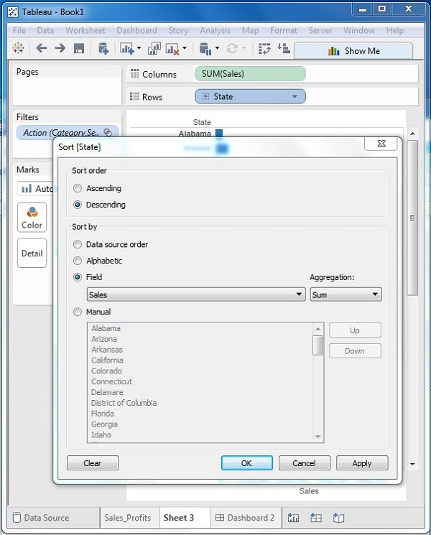
FIG NO. 6.1.1 : CREATING MULTIPLE SHEET
Step 3 − Next, create a blank dashboard by clicking the Create New Dashboard link at the bottom of the workbook. Right-click and rename the dashboard as Employee Attrition Dashboard.

FIG NO. 6.1.2 : BLACK DASHBOARD SHEET
Step 4 − Drag the two worksheets to the dashboard. Near the top border line of Total Number of Employee with respect to department worksheet, you can see three small icons. Click the middle one, which shows the prompt Use as Filter on hovering the mouse over it.
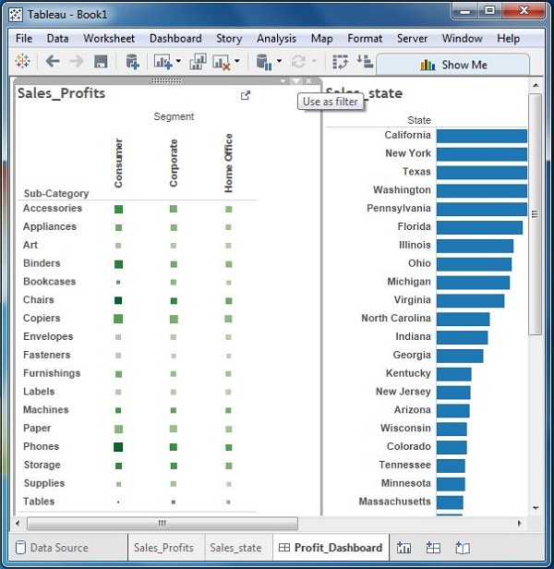
FIG NO. 6.1.4 : COMBINING MULTIPLE WORKSHEET
Step 5 − Now in the dashboard, click the box representing Sub-Category named Machines and segment named Consumer. You can notice that only the states where the sales happened for this amount of profit are filtered out in the right pane named Resignation Prediction. This illustrates how the sheets are linked in a dashboard.
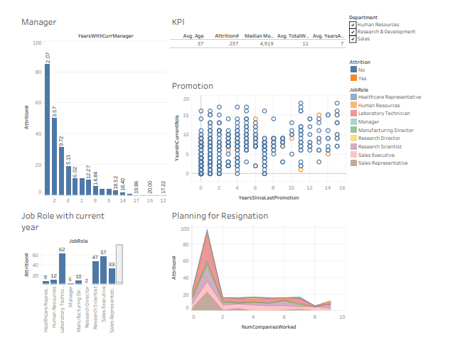
FIG NO. 6.1.5: EMPLOYEE ATTRITION DASHBOARD
CHAPTER – 8
CONCLUSION
The above study is about the high attrition rate. High attrition rate will hampers the workflow of the organization. The attrition rate needs to be reduced by a proper research to solve the issue. High attrition will lead to increase in the recruitment cost and training and development cost of the new employee. Big data analytics is very helpful for the organization. It helps to modulate a proper plan to minimize the high attrition rate with proper management strategies. It helps to track and chart the behaviour of the employee and is used to help the employee with proper guidance and training. HR Analytics uses BADIR Framework to minimize the High Rate of Attrition.

CHAPTER – 8

Expert Comments

Tableau Data Analysis tool should create confidence in their employee by considerable investment in business, they hire services from other service providers instead of this they should go for collaborations and that too with good companies. Who are
number br 2 in their respective sector, if you hire services of number 4-5 in that
sector Quality and Overall Efficiency goes down. More importantly, a Tableau service
provider should understand the company’s business first, then should create a
flexible environment for their customer and should allow two way interactions.
Particularly, in the business of Pharmaceuticals, Tableau service provider must be
made is mind to face the hassles in Licensing, Drug Regulation Acts, Authorized
Signatory, etc.

Tableau players must understand that they provide Place utility, out of 4 P’s of the
business utilities, so they should consider it as prime focus to provide the Place
Utility to their customers. As far as pricing is concerned, they should consider an overall Profitability in the business instead of trying to generate profit at each link of the chain.
In literal sense, 3 PL must act as a Shadow of their customer without any self-policies, even with flexible IT systems.

Mr. Mohammed Tanzeem Agra
CEO – XERXEZ SOLUTIONS

Bibliography
SL No | RESOURCES
1. | Angrave, D., Charlwood, A., Kirkpatrick, I., Lawrence, M., & Stuart, M. (2016). HR andanalytics: why HR is set to fail the big data challenge. Human Resource ManagementJournal, 26(1), 1-11.
2. | Fabius, R., Loeppke, R. R., Hohn, T., Fabius, D., Eisenberg, B., Konicki, D. L., & Larson, P.(2016).Tracking the market performance of companies that integrate a culture ofhealth and safety: an assessment of corporate health achievement awardapplicants.Journal of occupational and environmental medicine, 58(1), 3-8.
3. | Holsapple, C., Lee-Post, A., & Pakath, R. (2014).A unified foundation for business analytics. Decision Support Systems, 64, 130-141.
4. | Kocakulah, M. C., Kelley, A. G., Mitchell, K. M., & Ruggieri, M. P. (2016). Absenteeism problems and costs: causes, effects and cures. The International Business &Economics Research Journal (Online), 15(3), 89-92.
5. | Laursen, G. H., &Thorlund, J. (2016).Business analytics for managers: Taking business intelligence beyond reporting. John Wiley & Sons.
6. | Marler, J. H., & Boudreau, J. W. (2017).An evidence-based review of HR Analytics.TheInternational Journal of Human Resource Management, 28(1), 3-26.
7. | McLean, S., Stakim, C., Timner, H., & Lyon, C. (2016). Big Data and Human Resources:Letting the Computer Decide?.Scitech Lawyer, 12(2), 20-25.

